PROLOG PROBLEMS
Name: S Durga Prasad
Reg No:192472091
1.Basic Calculator
Program:
calculator(A, B) :-
Sum is A + B,
Difference is A - B,
Product is A * B,
Division is A / B,
write('S Durga Prasad ,Reg No: 192472091 calculator'),nl,
write('Addition = '), write(Sum), nl,
write('Subtraction = '), write(Difference), nl,
write('Multiplication = '), write(Product), nl,
write('Division = '), write(Division), nl.
OUTPUT:
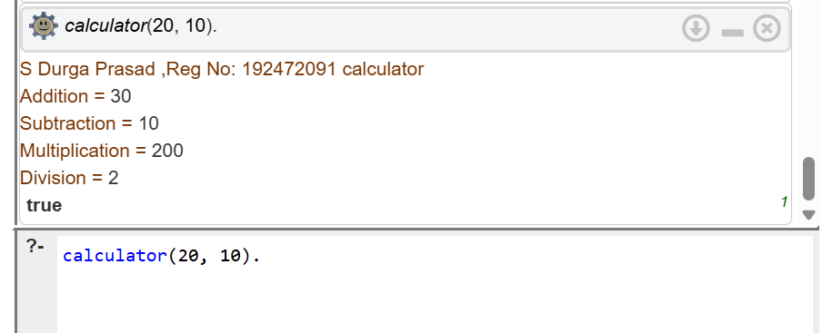

2.All comparsion
Program:
compare(A, B) :-
write('Name : S Durga Prasad'), nl,
write('Reg No : 192472091'), nl,
nl,
(A > B ->
write('A is greater than B')
;
A < B ->
write('A is less than B')
;
write('A is equal to B')
).
OUTPUT:
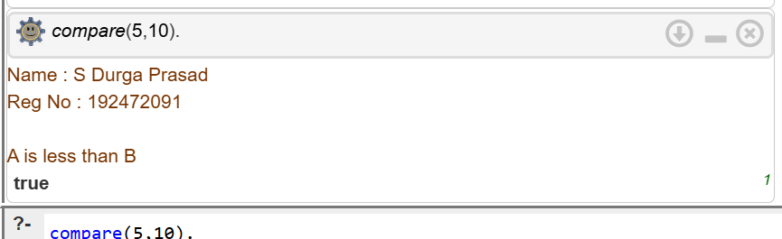

3.VOTE ELIGIBILITY
Program:
vote :-
write('Name : S Durga Prasad'), nl,
write('Reg No : 192472091'), nl,
nl,
write('Enter your age: '),
read(Age),
(Age >= 18 ->
write('You are eligible to vote.')
;
write('You are not eligible to vote.')
),
nl.
OUTPUT:
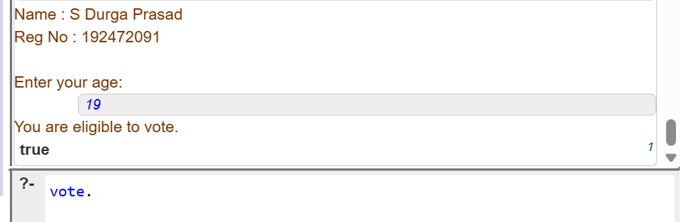

4. celsius_to_fahrenheit
Program:
celsius_to_fahrenheit :-
write('Name : S Durga Prasad'), nl,
write('Reg No : 192472091'), nl,
nl,
write('Enter temperature in Celsius: '),
read(C),
F is (C * 9 / 5) + 32,
write('Temperature in Fahrenheit = '),
write(F),
nl.
OUTPUT:
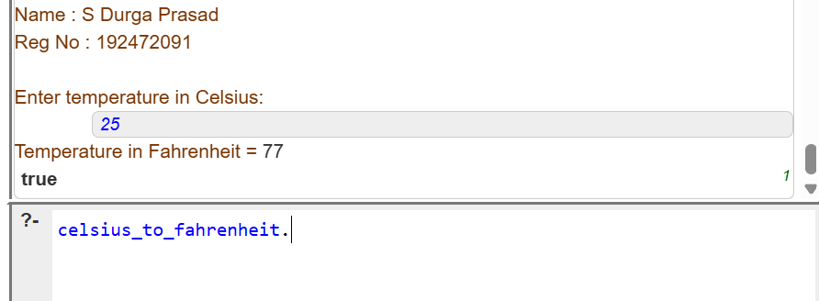
5.Pass/Fail 3 sub
Program:
result(M1, M2, M3) :-
write('Name : S Durga Prasad'), nl,
write('Reg No : 192472091'), nl,
nl,
write('Subject 1 Mark: '), write(M1), nl,
write('Subject 2 Mark: '), write(M2), nl,
write('Subject 3 Mark: '), write(M3), nl,
nl,
(M1 >= 40, M2 >= 40, M3 >= 40 ->
write('Result: PASS')
;
write('Result: FAIL')
),
nl.
OUTPUT:
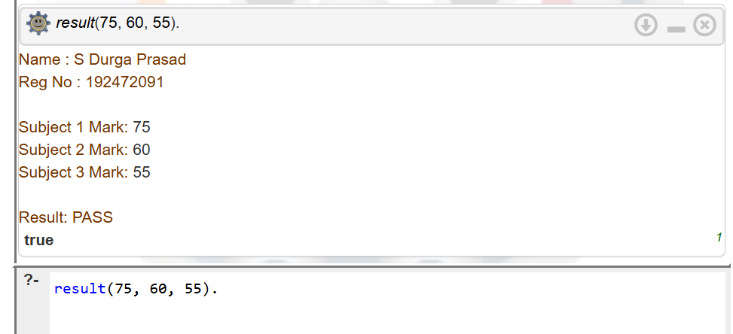

6. Avg of 5 numbers
Program:
average :-
write('Name : S Durga Prasad'), nl,
write('Reg No : 192472091'), nl,
nl,

write('Enter first number: '), read(A),
write('Enter second number: '), read(B),
write('Enter third number: '), read(C),
write('Enter fourth number: '), read(D),
write('Enter fifth number: '), read(E),

Sum is A + B + C + D + E,
Avg is Sum / 5,

nl,
write('Average = '), write(Avg), nl.
OUTPUT:
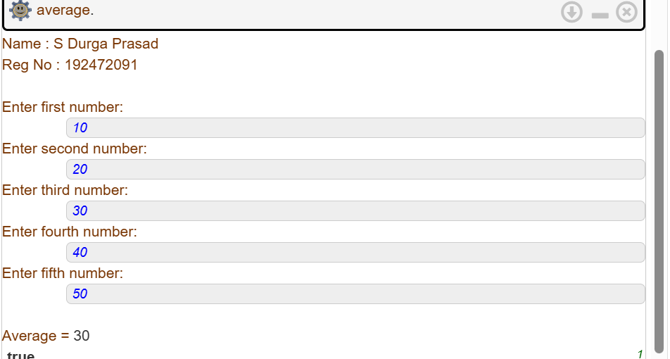
7.Multiplication Table:
table(N, I) :-
I =< 10,
Result is N * I,
write(N), write(' x '), write(I),
write(' = '), write(Result), nl,
I1 is I + 1,
table(N, I1).

table(N) :-
write('Name : S Durga Prasad'), nl,
write('Reg No : 192472091'), nl,
nl,
write('Enter a number: '),
read(N),
table(N, 1).
OUTPUT:
Name : S Durga Prasad
Reg No : 192472091
Enter a number: 5.
5 x 1 = 5
5 x 2 = 10
5 x 3 = 15
5 x 4 = 20
5 x 5 = 25
5 x 6 = 30
5 x 7 = 35
5 x 8 = 40
5 x 9 = 45
5 x 10 = 50 true.
8. Student teacher subject relation:
Program:
studies(prasad, prolog).
studies(raju, dbms).
studies(sita, python).

% Teacher and the subject they teach
teaches(prakash, prolog).
teaches(ravi, dbms).
teaches(anu, python).

% Display student, teacher and subject
relation(Student, Teacher, Subject) :-
studies(Student, Subject),
teaches(Teacher, Subject),
write('Name : S Durga Prasad'), nl,
write('Reg No : 192472091'), nl,
nl,
write('Student : '), write(Student), nl,
write('Teacher : '), write(Teacher), nl,
write('Subject : '), write(Subject), nl.

OUTPUT:
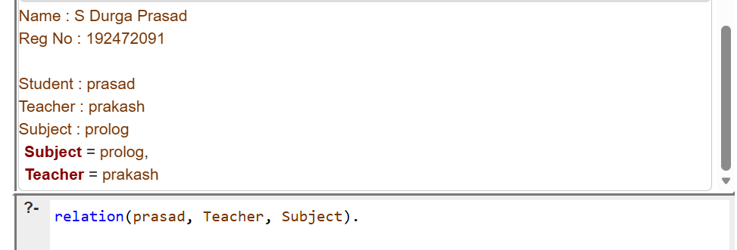

9. Family tree – all realtion
Program:
parent(john, mary).
parent(john, peter).
parent(susan, mary).
parent(susan, peter).

parent(peter, tom).
parent(peter, anna).
parent(lisa, tom).
parent(lisa, anna).

% Male and Female
male(john).
male(peter).
male(tom).

female(susan).
female(mary).
female(lisa).
female(anna).

% Father
father(X, Y) :-
male(X),
parent(X, Y).

% Mother
mother(X, Y) :-
female(X),
parent(X, Y).

% Child
child(X, Y) :-
parent(Y, X).

% Son
son(X, Y) :-
male(X),
parent(Y, X).

% Daughter
daughter(X, Y) :-
female(X),
parent(Y, X).

% Brother
brother(X, Y) :-
male(X),
parent(P, X),
parent(P, Y),
X \= Y.

% Sister
sister(X, Y) :-
female(X),
parent(P, X),
parent(P, Y),
X \= Y.

% Grandfather
grandfather(X, Y) :-
male(X),
parent(X, Z),
parent(Z, Y).

% Grandmother
grandmother(X, Y) :-
female(X),
parent(X, Z),
parent(Z, Y).

% Grandchild
grandchild(X, Y) :-
parent(Y, Z),
parent(Z, X).

% Uncle
uncle(X, Y) :-
male(X),
parent(P, Y),
brother(X, P).

% Aunt
aunt(X, Y) :-
female(X),
parent(P, Y),
sister(X, P).

% Display student details
show_details :-
write('Name : S Durga Prasad'), nl,
write('Reg No : 192472091'), nl.
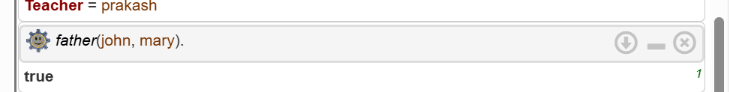
10 Dieting system based disease
Program:
diet(diabetes) :-
write('Recommended Diet: Vegetables, whole grains and low-sugar foods.'), nl.

diet(obesity) :-
write('Recommended Diet: Fruits, vegetables and low-fat foods.'), nl.

diet(hypertension) :-
write('Recommended Diet: Low-salt foods, fruits and vegetables.'), nl.

diet(anemia) :-
write('Recommended Diet: Iron-rich foods such as spinach, beans and lentils.'), nl.

diet(ulcer) :-
write('Recommended Diet: Soft foods and avoid spicy foods.'), nl.

diet(_) :-
write('Disease not found in the system.'), nl.

start :-
write('Name : S Durga Prasad'), nl,
write('Reg No : 192472091'), nl,
nl,
write('Enter disease: '),
read(Disease),
diet(Disease).
OUTPUT:
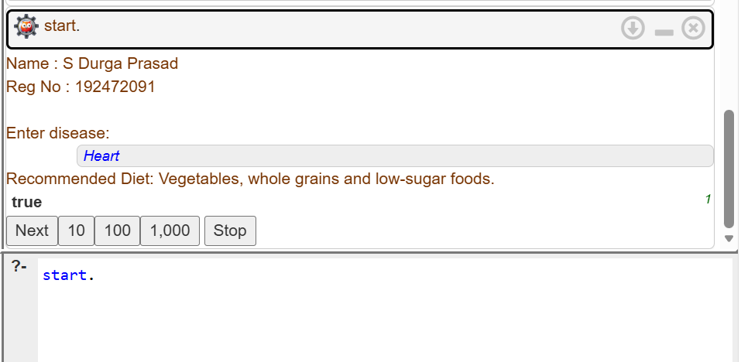

11. Forward / backward chaining
Program:
bird(parrot).
has_feathers(parrot).

% Rules
animal(X) :-
bird(X).

can_fly(X) :-
bird(X),
has_feathers(X).

% Display details
start :-
write('Name : S Durga Prasad'), nl,
write('Reg No : 192472091'), nl,
nl,
write('Forward / Backward Chaining'), nl,
nl,
write('Bird: parrot'), nl,
write('Feathers: yes'), nl,
write('Animal: '),
(animal(parrot) -> write('Yes') ; write('No')),
nl,
write('Can Fly: '),
(can_fly(parrot) -> write('Yes') ; write('No')),
nl.
OUTPUT:
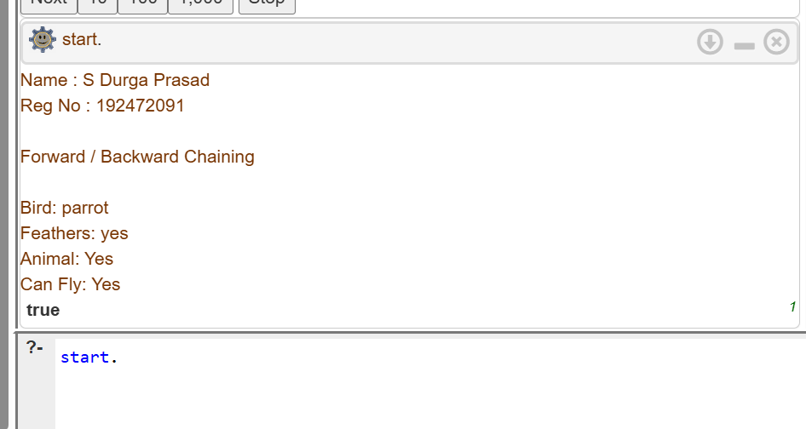
12. Monkey banana problem
Program:
monkey(at_door).
banana(on_ceiling).
box(in_room).

% Monkey can move to the box
move_monkey :-
monkey(at_door),
write('Monkey moves to the box.'), nl.

% Monkey pushes the box under the banana
push_box :-
write('Monkey pushes the box under the banana.'), nl.

% Monkey climbs the box
climb_box :-
write('Monkey climbs on the box.'), nl.

% Monkey gets the banana
get_banana :-
banana(on_ceiling),
write('Monkey gets the banana.'), nl.

% Main program
start :-
write('Name : S Durga Prasad'), nl,
write('Reg No : 192472091'), nl,
nl,
move_monkey,
push_box,
climb_box,
get_banana,
nl,
write('Monkey has the banana!'), nl.
OUTPUT:
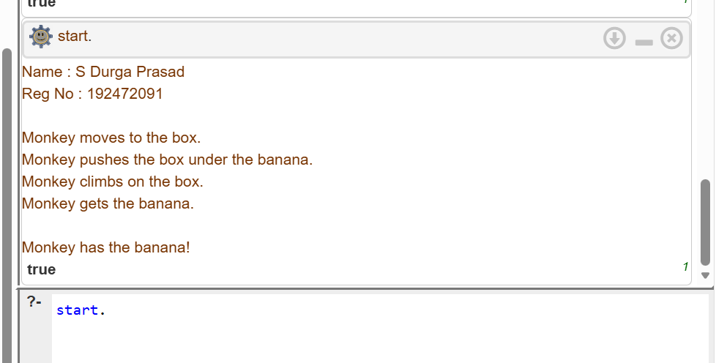
13. Fruit and color – backtracking
Program:
fruit(apple, red).
fruit(banana, yellow).
fruit(orange, orange).
fruit(grapes, green).
fruit(mango, yellow).

start :-
write('Name : S Durga Prasad'), nl,
write('Reg No : 192472091'), nl,
nl,
write('Fruit and Color:'), nl,
fruit(Fruit, Color),
write(Fruit),
write(' -> '),
write(Color),
nl,
fail.

start.
OUTPUT:
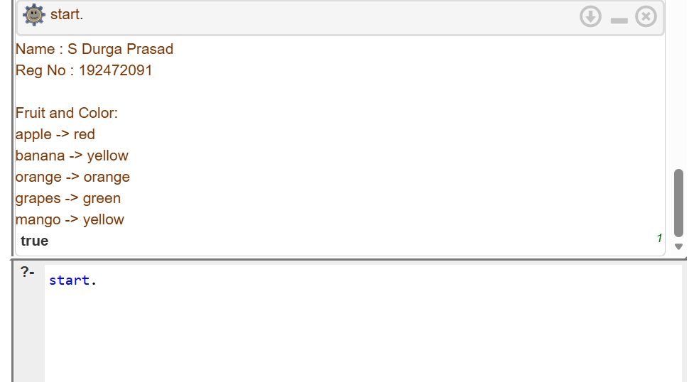
14. Bird fly or not
Program:
can_fly(X) :-
bird(X),
fly(X).

cannot_fly(X) :-
bird(X),
not_fly(X).

% Display details
start :-
write('Name : S Durga Prasad'), nl,
write('Reg No : 192472091'), nl,
nl,
write('Bird Fly or Not'), nl,
nl,
write('Parrot: '),
(can_fly(parrot) -> write('Can Fly') ; write('Cannot Fly')),
nl,
write('Eagle: '),
(can_fly(eagle) -> write('Can Fly') ; write('Cannot Fly')),
nl,
write('Penguin: '),
(can_fly(penguin) -> write('Can Fly') ; write('Cannot Fly')),
nl.
Program:
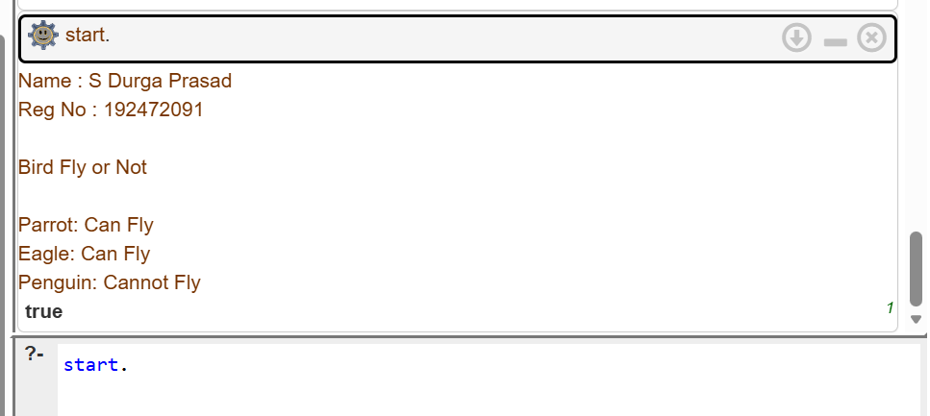

15. Grade find
Program:
grade(Mark, 'A') :-
Mark >= 90.

grade(Mark, 'B') :-
Mark >= 75,
Mark < 90.

grade(Mark, 'C') :-
Mark >= 60,
Mark < 75.

grade(Mark, 'D') :-
Mark >= 50,
Mark < 60.

grade(Mark, 'F') :-
Mark < 50.

% Main Program

main :-
write('Name : S Durga Prasad'), nl,
write('Reg No : 192472091'), nl,
nl,
write('Enter Marks: '),
read(Mark),
grade(Mark, Grade),
write('Grade: '),
write(Grade),
nl.
OUTPUT:
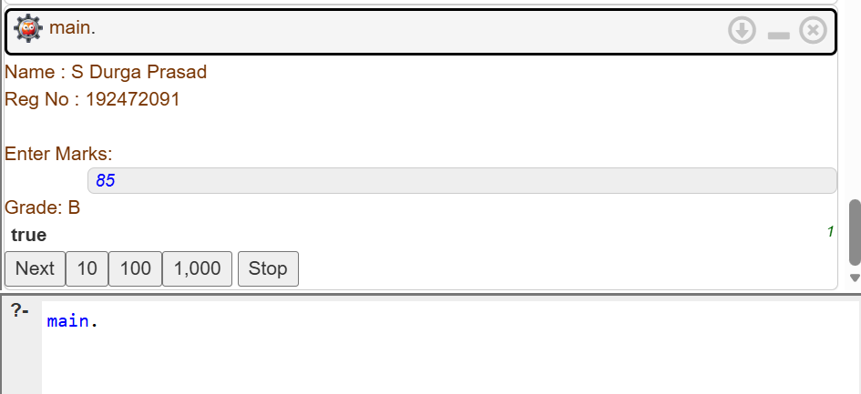

16. EB bill Program
bill(Units, Amount) :-
Units =< 100,
Amount is Units * 2.

bill(Units, Amount) :-
Units > 100,
Units =< 200,
Amount is (100 * 2) + ((Units - 100) * 3).

bill(Units, Amount) :-
Units > 200,
Amount is (100 * 2) + (100 * 3) + ((Units - 200) * 5).

% Main Program

main :-
write('Name : S Durga Prasad'), nl,
write('Reg No : 192472091'), nl,
nl,
write('EB BILL CALCULATION'), nl,
nl,
write('Enter Units Consumed: '),
read(Units),
bill(Units, Amount),
write('Units Consumed : '), write(Units), nl,
write('EB Bill Amount : Rs.'), write(Amount), nl.

OUTPUT:
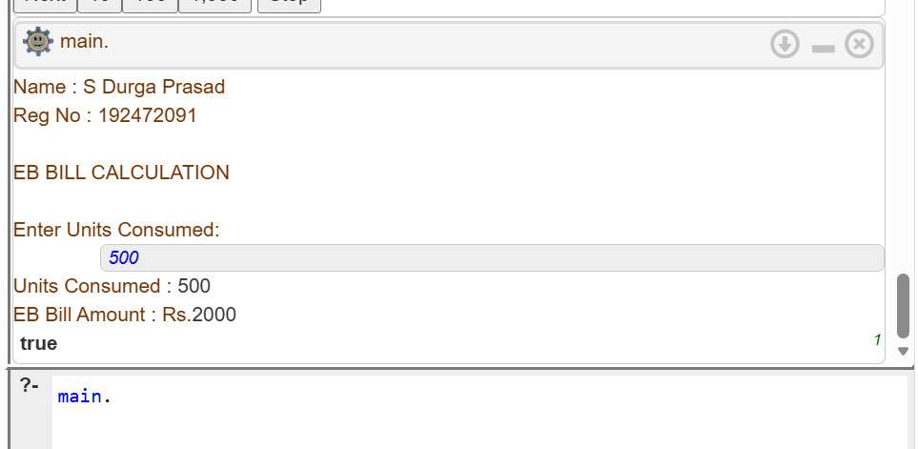

17. Student database
Program:
student(101, 'Ravi', cse).
student(102, 'Arun', ece).
student(103, 'Priya', cse).
student(104, 'Kiran', aiml).

% Main Program

main :-
write('Name : S Durga Prasad'), nl,
write('Reg No : 192472091'), nl,
nl,
write('STUDENT DATABASE'), nl,
nl,
write('Student Details:'), nl,
student(Roll, Name, Department),
write('Roll No: '), write(Roll),
write(' Name: '), write(Name),
write(' Department: '), write(Department), nl,
fail.

main.
OUTPUT:
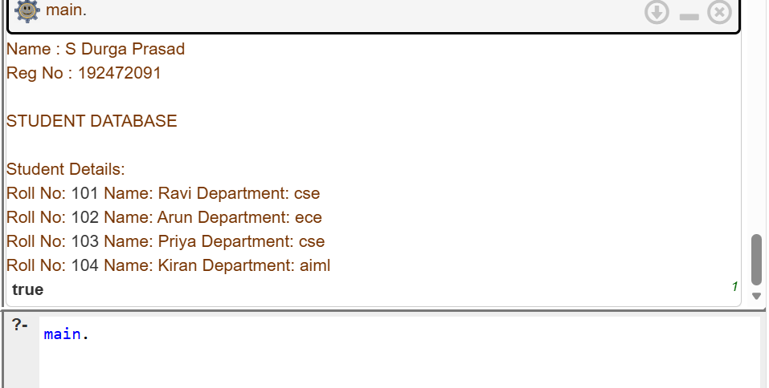
18. Print 1 to 10
Program:
print_numbers(10).

print_numbers(N) :-
N < 10,
M is N + 1,
write(M), nl,
print_numbers(M).

% Main Program

main :-
write('Name : S Durga Prasad'), nl,
write('Reg No : 192472091'), nl,
nl,
write('Numbers from 1 to 10:'), nl,
write(1), nl,
print_numbers(1).
OUTPUT:
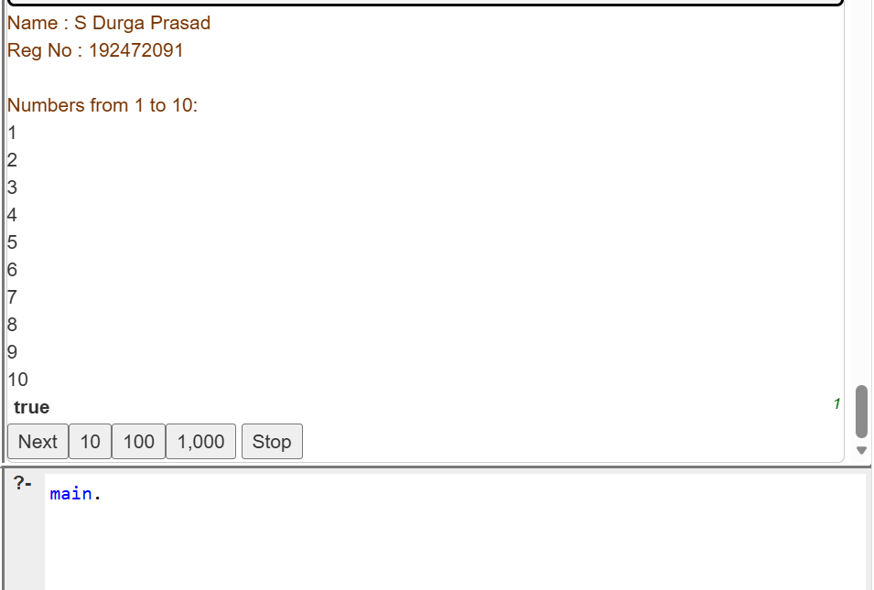

19. N queens Problem
Program:
safe([]).

safe([Q|Queens]) :-
safe(Queens),
not_attack(Q, Queens, 1).

not_attack(_, [], _).

not_attack(Q, [Q1|Queens], Distance) :-
Q =\= Q1,
abs(Q - Q1) =\= Distance,
D2 is Distance + 1,
not_attack(Q, Queens, D2).

% Generate a solution

queens(N, Solution) :-
length(Solution, N),
permutation_list(Solution),
safe(Solution).

permutation_list([]).

permutation_list(List) :-
length(List, N),
num_list(1, N, Numbers),
permutation(Numbers, List).

num_list(Start, End, []) :-
Start > End.

num_list(Start, End, [Start|Rest]) :-
Start =< End,
Next is Start + 1,
num_list(Next, End, Rest).

% Main Program

main :-
write('Name : S Durga Prasad'), nl,
write('Reg No : 192472091'), nl,
nl,
write('N-Queens Problem'), nl,
nl,
write('Solution for 4 Queens:'), nl,
queens(4, Solution),
write(Solution), nl.
OUTPUT:
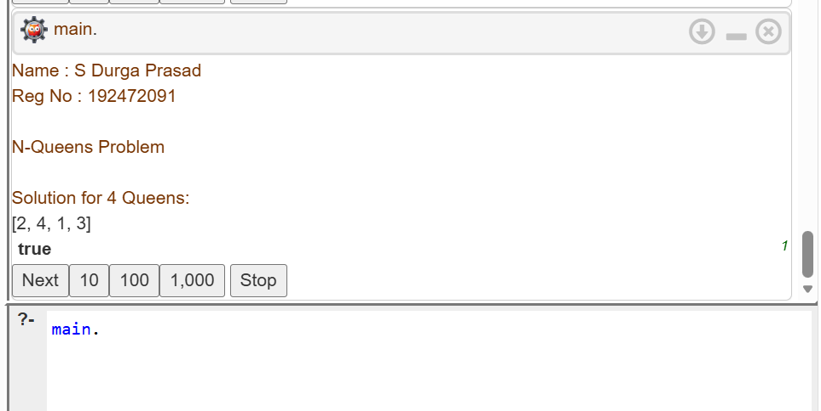
20. Reverse a number
Program:
reverse_number(0, 0).

reverse_number(N, Reverse) :-
N > 0,
reverse_helper(N, 0, Reverse).

reverse_helper(0, Result, Result).

reverse_helper(N, Result, Reverse) :-
N > 0,
Digit is N mod 10,
NewResult is Result * 10 + Digit,
NewN is N // 10,
reverse_helper(NewN, NewResult, Reverse).

% Main Program

main :-
write('Name : S Durga Prasad'), nl,
write('Reg No : 192472091'), nl,
nl,
write('REVERSE A NUMBER'), nl,
nl,
write('Enter a number: '),
read(Number),
reverse_number(Number, Reverse),
write('Original Number : '), write(Number), nl,
write('Reversed Number : '), write(Reverse), nl.
OUTPUT:
